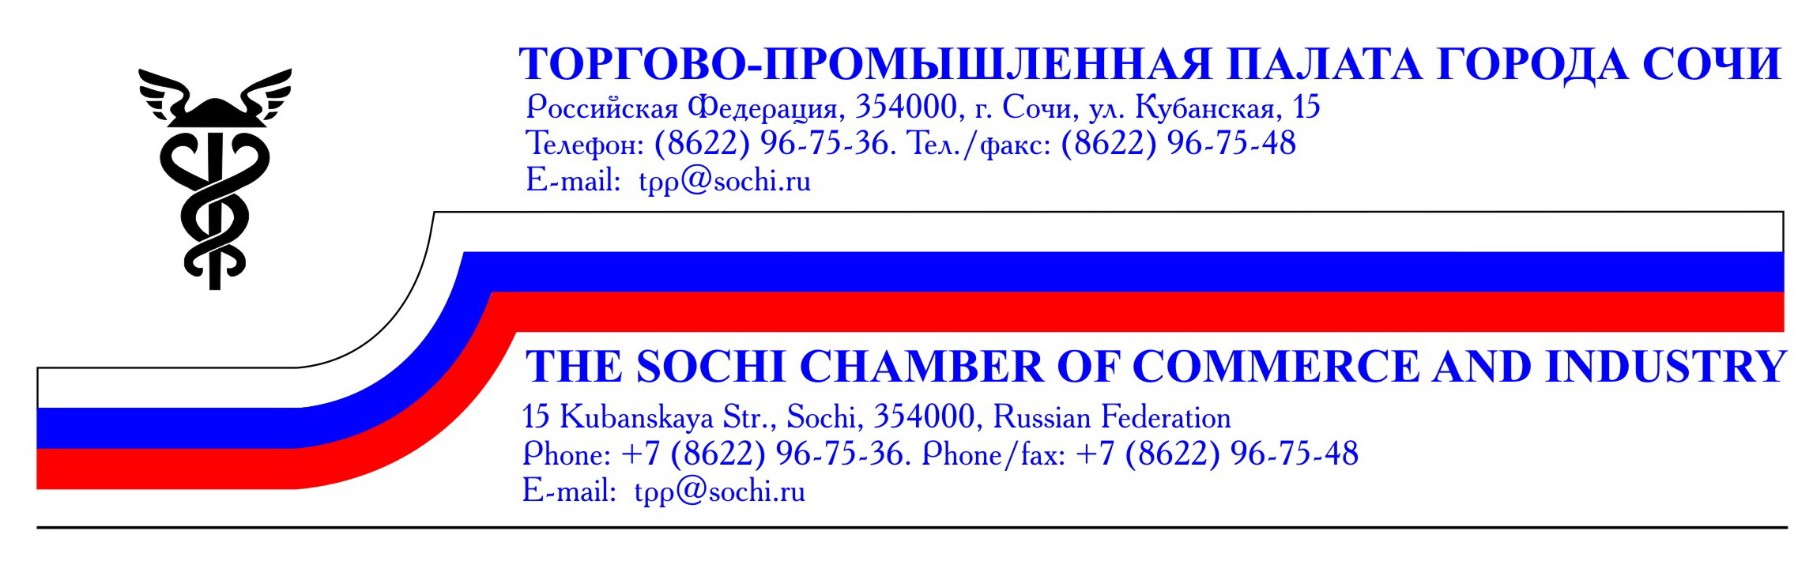
Dear Ladies and Gentlemen!
We invite you to the City of Sochi to take part in the Fest and Congress of Cheesemakers and Winemakers within the event becoming annual. We have provided a background for face-to-face contacts and conclusion of supply contracts between manufacturers and sellers!

CHEESE. WINE. SOCHI-2015 Fest
Congress of Cheesemakers and Winemakers of Russia

October 30 - November 01, 2015
Sochi, Yuzhny Mol Square

Fest Organizers – Convention Bureau of the Sochi Commerce and Industry Chamber with the assistance of the Administration of the Krasnodar Territory and the Administration of the City of Sochi, the Ministry of Agriculture and Processing Industry of the Krasnodar Territory.

Fest Objectives:
- creating a platform for conclusion of supply contracts with enterprises belonging to the sanatorium-resort industry and HoReCa;
- support to Russian cheesemakers and winemakers;
- promotion of culture of wine consumption;
- presentation of unknown foreign cheese and wine assortments as well as their manufacturers to Sochi citizens and city guests;
- cultural and entertaining events;
- increasing manufacturers' sale results;
- building business and partner relationships between participants.

Participants:
The participants of the Fest are large and small-size Russian and foreign manufacturers of cheese and wine, companies engaged in supplying of these products, whole sellers and retailers, trading and dealer companies presenting goods accompanying cheese and wine, enterprises of the HoReCa sector that is hotels, restaurants, bars and cafes, companies of the sanatorium-resort industry who submitted an application for participation to the Fest organizing committee and paid a registration fee.

Fest Visitors: over 5,000 guests are expected to visit the Fest.

The Trade Fair for selling cheese, wine and other food products, tasting and presentation events, cooking master-classes, lectures and seminars on choosing cheese appetizers for certain sorts of wine will be held as a part of the Fest.

Entertaining program includes performances of folk groups from different regions participating in the Fest and dancing groups from Sochi, movie screening, land-art areas and contests. In connection with the Year of Literature the Theatre Square of the Fest will house the performances of amateur theatres of the Krasnodar Territory.

The creators from Sochi and Russia will present their hand-made works - pictures, souvenirs, interior objects, dishware for cheese and wine - at the Sun Flavour Crafts Fair.

The business program of the Fest includes All-Russian Congress of Cheesemakers and Winemakers which will consider the problems of manufacture, logistics, sale, support programs for manufacturers and others.
The managers of food retail chains and sanatorium-resort industry of the Krasnodar Territory and from other regions are invited to the Congress for discussion of cooperation and conclusion of supply contracts.

The planning Geography of the Fest Participants: Sochi, the Krasnodar Territory, Adygea, the Crimea, Armenia, Abkhazia, Belorussia, Moldova. Italy, Turkey, Mexico are invited as foreign guests.

Arguments FOR Participation in the Fest:

- An opportunity to conclude direct contracts with restaurants, sanatoriums, trading companies from different regions and countries.
- An increase of sale results connected with products and services.
- Extending of your production awareness.
- Developing confidence in your production brand / trade mark.
- Central dislocation of the event.
- A great number of visitors planned.
- A large advertisement and information support of the Fest (the Internet, mass media, TV, printed communications, outdoor advertizing).
Conditions of participation in the Trade Fair of the Cheese. Wine. Sochi-2015 Fest*:
● Obligatory registration fee for a region / country (accreditation, publication in the Fair participant catalogue about each region/country representative on a 1/4 page, posting information about the region/country in the Internet, security and cleaning services during off hours (badges, a banquet, a tour for 1 person) | 14 900 rubles
● Equipped exhibition stand (a standard plastic module, fascia, power supply, a table, two chairs, a waste-paper basket). | 6 900 rubles per 1 m²
● Work place (a table + two chairs) 2 m² of the open-space area | 15 900 rubles
● Virtual participation (publication in the participant catalogue, distribution of advertizing materials at the Fair, information about the company in the Internet, shipment of financial documents and a catalogue copy). | 9 900 rubles

* Conditions of participation in the Congress of Cheesemakers and Winemaker are to be sent on request!
We render services of accommodation in hotels and providing transfers.
To participate in the Fair you need: to complete an application agreement, to submit a construction scheme and a text for the catalogue. Then, to pay for participation within 2 working weeks after invoicing. Applications will be accepted till August 20, 2015.
All services are rendered against a 100% payment under condition of timely execution of documents and submission of materials! ATTENTION! VAT not payable!
ORGANIZING COMMETTE: 15, Kubanskaya Street, Sochi, 354000. Tel./Fax: (862) 296-75-48 www.sochi.tpprf.ru
Fest Director: Natalja Zhdanova, tel. 8-918-909-13-04, e-mail: cb.tppsochi@mail.ru
Project Manager: Veronika Tarasevich, tel. 8-918-615-51-08, e-mail: cbtpp@mail.ru

